

Southern Luzon State University
COLLEGE OF ENGINEERING
Computer Engineering Department
Lucban, Quezon

CPE22L: Digital Signal Processing Laboratory

Activity # 4: Fourier Series/ Fourier Transform

PADUADA, Dave Jhared G.

DOP: Oct 8, 2025
DOS: Oct 15, 2025

RATING

Engr. Ralph Monsour Delima
INSTRUCTOR

- Objectives
1. To understand Fourier series/Fourier Transform representation of periodic signals.
2. To learn how to use MATLAB to find the Fourier Series/Fourier Transform of a discrete signal.
3. To identify the functions of Fourier series and Fourier transform and how they work
- Introductory Information

Use the uploaded Introductory information in the GCR
- Data & Procedures

- LINEARITY of a Discrete Time System
The response of the system to a weighted sum of signals is equal to the corresponding weighted sum of the responses (outputs) of the system to each of the individual input signals.
Method of Proof:
Individual inputs are applied, and the weighted sum of the output is taken. Then the weighted sum of signals input is applied to the system and the outputs are checked to see if they are equal.

%Program P4_1  clf;  N = 1000;  x = linspace(-1,1,N);  f = sign(x);  sum = 0.*x;  M = input('Number of coefficient (M):');  for j = 1:2:M  sum = sum + 4/pi*sin(j*pi*x)/j;  end  subplot(2,1,1);  plot(x, sum, 'r')  xlabel('Time index n');ylabel('Amplitude');  title('Fourier Series with M=1');  hold on  plot(x,f,'LineWidth',2)  hold on  subplot(2,1,2);;  error = abs(sum-f);  plot(x,error);  xlabel('Time index n');ylabel('error');  title('Error with M=1'); | % Program P4_2  Program 4_2  Matlab Code for Discrete Fourier Transform  x = [2 3 -1 1];  N = length(x);  X = zeros(4,1)  for k = 0:N-1  for n = 0:N-1  X(k+1) = X(k+1) + x(n+1)*exp(-i*pi/2*n*k)  end  end  t = 0:N-1  subplot(311)  stem(t,x);  xlabel('Time (s)');  ylabel('Amplitude');  title('Time domain - Input sequence')  subplot(312)  stem(t,X)  xlabel('Frequency');  ylabel('|X(k)|');  title('Frequency domain - Magnitude response')  subplot(313)  stem(t,angle(X))  xlabel('Frequency');  ylabel('Phase');  title('Frequency domain - Phase response')  X % to check |X(k)|  angle(X) % to check phase
Program 4_3
Matlab Code for Fast Fourier Transform
N=4;
x=[2 3 -1 1];
t=0:N-1;
subplot(311)
stem(t,x);
xlabel('Time (s)');
ylabel('Amplitude');
title('Input sequence')
subplot(312);
stem(0:N-1,abs(fft(x)));
xlabel('Frequency');
ylabel('|X(k)|');
title('Magnitude Response');
subplot(313);
stem(0:N-1,angle(fft(x)));
xlabel('Frequency');
ylabel('Phase');
title('Phase Response');

- Data and Results
- Approximating with Fourier Sine Series
Q4.1 Run Program P4_1 and generate the Fourier series for square wave. | 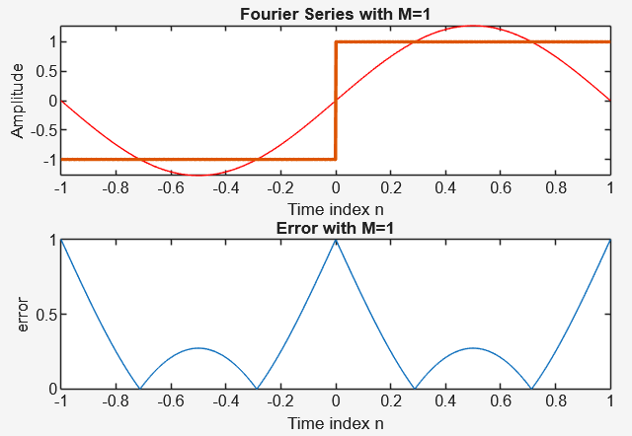  The output typically features a plot of the ideal square wave, the reconstructed waveform using the first M sine coefficients, and optionally a partial-sum error plot showing the discrepancy between the reconstructed signal and the ideal.
Q4.2 What will happen if the number of coefficient M is changed to 10? Discuss the result. | 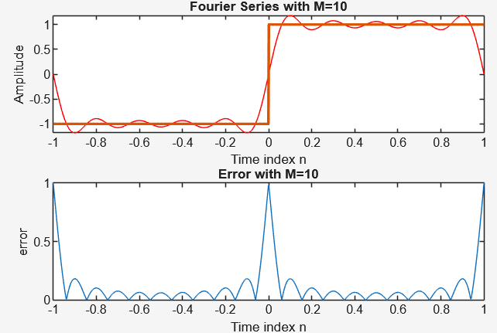  When using 10 harmonics, the reconstructed wave looks similar to a square wave but has rounded edges and smooth transitions. There are visible ripples or “ringing” near the sharp edges because the Fourier series doesn’t include enough high-frequency components to make clean transitions.
Q4.2 What will happen if the number of coefficient M is changed to 50? Discuss the result. | 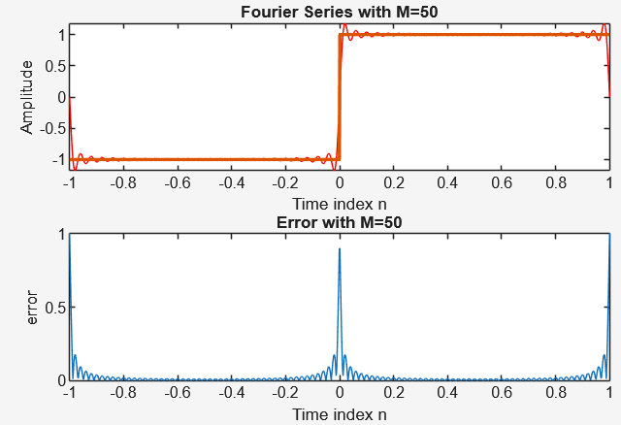  With 50 harmonics, the reconstructed wave looks closer to the ideal square wave, showing flatter tops and sharper edges. However, you can still see the Gibbs phenomenon, where overshoots and small ripples appear near the edges. The size of the overshoot stays about the same, but the affected area becomes narrower as more harmonics are added.
Q4.2 What will happen if the number of coefficient M is changed to 100? Discuss the result. | 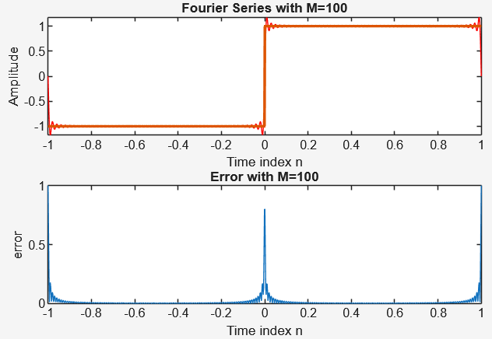  When using 100 harmonics, the waveform is very close to a perfect square wave. The tops are nearly flat, and the transitions are sharp. The edge ripples (Gibbs ripples) are smaller in width but still have similar height as before. This gives a very accurate and visually clean approximation, useful for engineering and visualization.
Q4.2 What will happen if the number of coefficient M is changed to 1000 ? Discuss the result. | With 1000 harmonics, the reconstructed signal almost perfectly matches the ideal square wave, with very flat regions and sharp transitions. The Gibbs overshoot still exists but is so narrow that it’s often invisible on a normal plot. This shows that adding more harmonics increases accuracy, but the waveform never perfectly matches the ideal square wave at the discontinuities. True convergence only happens in the average (mean-square) sense and away from the edges.  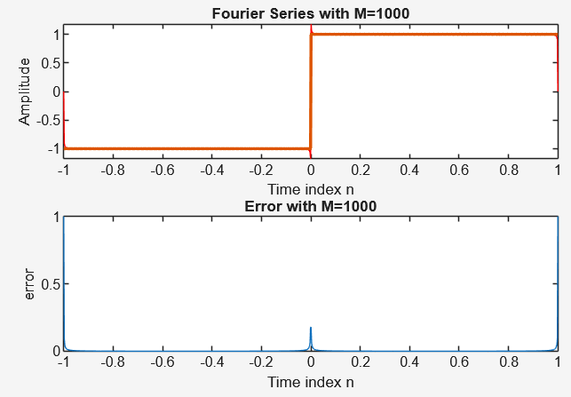
- Fourier Transform
Q4.3 Run Program P4_2 and generate the Discrete Fourier Transform. | 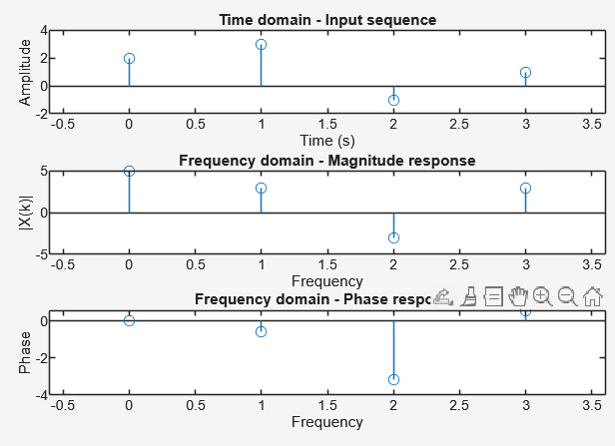  Running Program P4_2 performs a Discrete Fourier Transform (DFT) on a signal and produces two main plots:The magnitude spectrum, showing how strong each frequency is, and The phase spectrum, showing the time shift of each frequency component. Together, these help analyze the signal’s frequency content, periodicity, and energy distribution.
Q4.4 Create a Matlab code that will calculate the five-point DFT of the aperiodic sequence 𝑥[𝑘] of length 𝑁 = 5 which is  defined as follows:  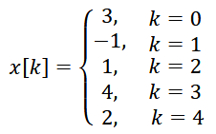 | 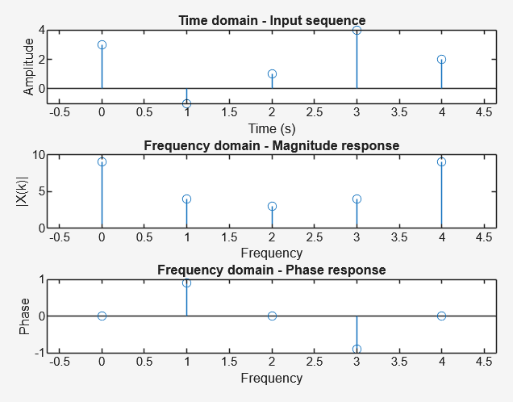  A 5-point DFT in MATLAB can be done by directly applying the DFT formula — looping through frequency indices and multiplying input samples by complex exponentials. This converts the signal from the time domain to the frequency domain, giving complex results that show the amplitude and phase of each frequency. The output shows which frequencies exist in the original signal and can be used for analysis or reconstruction using the inverse DFT.
Q4.5  Create a Matlab code that will calculate the inverse DFT of  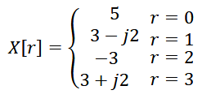 | 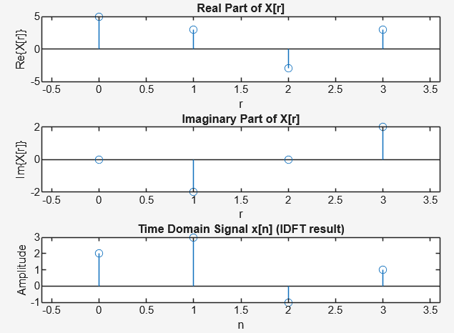  The inverse DFT rebuilds the original time-domain signal from its DFT values. This demonstrates that the DFT and inverse DFT are exact opposites of each other, allowing perfect conversion between time and frequency domains (aside from small rounding errors). | % Given frequency domain samples X[r]  X = [5, 3-1j*2, -3, 3+1j*2];  N = length(X);  % Initialize output x[n]  x = zeros(1, N);  % Compute inverse DFT manually  for n = 0:N-1  for r = 0:N-1  x(n+1) = x(n+1) + X(r+1) * exp(1j*2*pi*r*n/N);  end  x(n+1) = x(n+1) / N; % Divide by N for IDFT  end  % Display results  n = 0:N-1;  disp('Inverse DFT x[n] = ');  disp(x);  % Plot results  subplot(311);  stem(n, real(X));  xlabel('r');  ylabel('Re\{X[r]\}');  title('Real Part of X[r]');  subplot(312);  stem(n, imag(X));  xlabel('r');  ylabel('Im\{X[r]\}');  title('Imaginary Part of X[r]');  subplot(313);  stem(n, real(x));  xlabel('n');  ylabel('Amplitude');  title('Time Domain Signal x[n] (IDFT result)');
- Fast Fourier Transform
Q. 4.6  Run Program P4_3 and generate the Fast Fourier Transform | 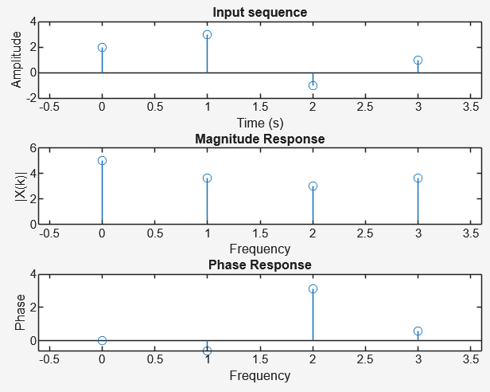  Running Program P4_3 performs the Fast Fourier Transform (FFT), a faster way to compute the DFT. The FFT gives the same magnitude and phase plots as the DFT but takes much less time to calculate. Because of its efficiency, the FFT is widely used in digital audio, communications, and image processing, providing the same accuracy as the DFT.
Q4.7. Generate the Fast Fourier Transform using the given in Q4.4. | 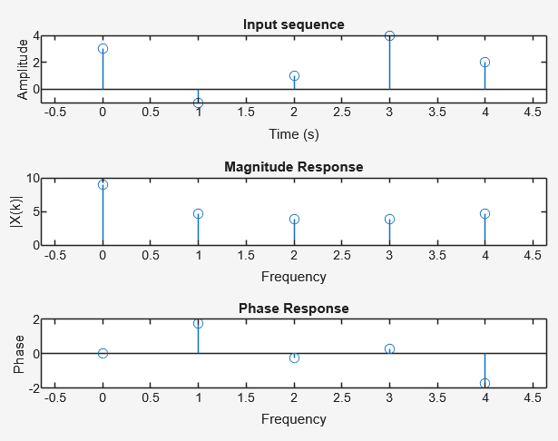  Applying the FFT to the same sequence from Q4.4 gives results that match the earlier DFT output — including the real, imaginary, magnitude, and phase values. Any small differences are due to rounding errors. This confirms that both FFT and DFT produce the same frequency-domain information, but the FFT is preferred for being much faster and more efficient with large data sets.

- Conclusion
Through these exercises, it was demonstrated that Fourier analysis enables signals to be represented in terms of their frequency components. The Fourier series shows that any periodic signal can be approximated by adding together sine waves, and increasing the number of harmonics results in a more accurate representation. The Discrete Fourier Transform (DFT) provides the frequency-domain view of discrete signals, while the Inverse DFT allows these signals to be reconstructed perfectly. The Fast Fourier Transform (FFT) performs the same function as the DFT but does so much more efficiently, making it highly suitable for real-time and large-scale signal processing. Overall, these experiments highlight how transforming signals into the Fourier domain offers valuable insight into their behavior, which is essential in many engineering applications such as communications, control systems, and digital signal processing.

